TROOP 227 PARENTS PERMISSION FORM

I hereby give my son/ward, ____________________________________, permission to go camping with St. Bonaventure Men’s Club Boy Scout Troop 227 to Pacifica District Camporee at Oak Canyon Park, Silverado, CA on April 8th – 10 th 2016. He is in good physical condition and currently not ill.

Should any illness or accident occur to him on the trip, I will not hold liable St. Bonaventure Parish, the Men’s Club, their officers or employees, or the Boy Scout Council of Orange County or Troop 227, its officers or leaders, for accidents or medical aid rendered and will reimburse them for medical or other expenses incurred in the care of my son/ward.

My son/ward may receive necessary first aid. He may receive medical attention by a duly licensed medical provider. He may be admitted to a hospital in the case of an emergency. This authorization is given pursuant to section 25.8 of the Civil Code of California and remains effective only for the event and dates listed above. Parents/Guardians will be contacted as soon as possible.

Insurance information (Please check one):
[ ] Scout will carry insurance card.
[ ] A copy of the front and back of the insurance card is attached.
[ ] I have provided insurance information to the Troop, and the information is still correct.
[ ] Scout does not have medical insurance.

List any restrictions on activities: __________________________________________________________

List all medications he will be bringing: _____________________________________________________

Parent/Guardian Emergency Contact: _______________________________________________________
Relationship: ____________________ Phone: ________________________________

Alternate Emergency Contact: ____________________________________________________________
Relationship: ____________________ Phone: ________________________________

Parent/Guardian Signature: ____________________________________ Date: ____________________

Please tear below line and retain for your information

Cost: $ 45
Bring: We will NOT be stopping for food,
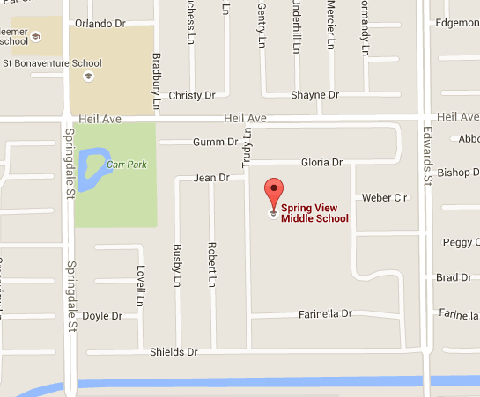
so please eat before departure.

Depart from: St. Bonaventure
(in front of flag pole)
Meet at: Arrive by 4:45 PM Friday evening
(Depart by 5:00 PM)

Pickup from: Spring View School
16662 Trudy Ln Huntington Beach
ETA: Aprox. 12 Noon Sunday

Scouts will call for pickup.

